Introduction

Time/Memory Limit Exceed
Two types of verdicts may appear to most of us while solving a problem, namely "Time Limit Exceeded" (TLE) and "Memory Limit Exceeded" (MLE). These errors mean that our solution maybe 100% correct, but it needs some optimization to be accepted. In such situations, we have to think of a better way to solve the problem or optimize the time or memory needed. Theoretically, a common computer can perform 10^9 operations in one second. However, practically, our code should not take more than 10^8 operations due to several factors, such as ignored factors in Big O notation and online judge limitations.
For example, if we are given 𝑛 (1 ≤ 𝑛 ≤ 10^5) and our complexity is, 𝑂(𝑛𝑙𝑜𝑔(𝑛)) ****which is about 10^6, it's fine. But if our complexity is 𝑂(𝑛^2), which is about 10^10, we will get a Time Limit Exceeded error.

How to determine the solution of a problem by looking at its constraints?
By looking at the constraints of a problem, we can often "guess" the solution.
Common time complexities
Let n be the main variable in the problem.
- If n ≤ 12, the time complexity can be O(n!).
- If n ≤ 25, the time complexity can be O($2^n$).
- If n ≤ 100, the time complexity can be O($n^4$).
- If n ≤ 500, the time complexity can be O($n^3$).
- If n ≤ $10^4$, the time complexity can be O($n^2$).
- If n ≤ $10^6$, the time complexity can be O(n log n).
- If n ≤ $10^8$, the time complexity can be O(n).
- If n > $10^8$, the time complexity can be O(log n) or O(1)

Common C++ functions could be used in problem solving:
Function name where to find function signature
Min
Max
Upper bound
Lower bound
Find
Sort
Swap
Pow
Sqrt
Gcd
Floor
Ceil
Abs
Isdigit
Reverse
Min element
Max element
Count
Next permutation
Prev permutation

Recursion

Binary Tree
Traverse A Tree

Binary Search Overview
In its simplest form, Binary Search operates on a contiguous sequence with a specified left and right index, called the Search Space. Binary Search maintains the left, right, and middle indices of the search space and compares the search target or applies a search condition to the middle value of the collection.
- If the condition is unsatisfied or values are unequal, the half in which the target cannot lie is eliminated.
- The search continues on the remaining half until it is successful.
- If the search ends with an empty half, the condition cannot be fulfilled, and the target is not found.
In the following chapters, we will:
- Review how to identify Binary Search problems
- Discuss reasons to use Binary Search
- Introduce the 3 different Binary Search templates
Since Binary Search is a common interview topic, we will categorize practice problems to different templates for you to practice.
Note:
Binary Search can take many alternate forms. It might not always be as straightforward as searching for a specific value. Sometimes you will need to apply a specific condition or rule to determine which side (left or right) to search next.

How to Identify Binary Search Problems
Binary Search is an algorithm that divides the search space in two after every comparison. Consider Binary Search whenever you need to search for an index or element in a collection. If the collection is unordered, you can always sort it first before applying Binary Search.

3 Parts of a Successful Binary Search
Binary Search is generally composed of three main sections:
- Pre-processing – Sort the collection if unsorted.
- Binary Search – Use a loop or recursion to divide the search space in half after each comparison.
- Post-processing – Determine viable candidates in the remaining space.

3 Templates for Binary Search

Template 1: Basic binary search
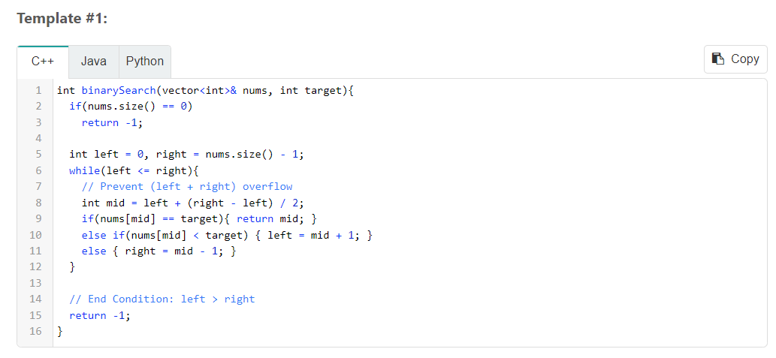
Key Attributes of Basic Binary Search
- The most basic and elementary form of Binary Search
- The search condition can be determined without comparing to the element's neighbors
- No post-processing required because, at each step, you are checking if the element has been found. If you reach the end without finding it, then it is not present in the collection.

Distinguishing Syntax of Binary Search
- Initial Condition: left = 0, right = length - 1
- Termination Condition: left > right
- Searching Left: right = mid - 1
- Searching Right: left = mid + 1

Template 2: Basic binary search

